**THE ONLINE SHARING EXAMINATION BOARD**

**PRIMARY THREE EXAMS**

**SCIENCE END TERM THREE 2023**

Name: …………………………………………..………………………………………………

**INSTRUCTIONS:**

1. Avoid unnecessary crossing of work.
2. Write well
3. Read the instructions carefully and answer all questions.
4. Wrong spellings will lead to loss of marks.
5. All work written in pencil **EXCEPT DIAGRAMS** will **NOT** be marked.

**SECTION A**

1. Name any **one** example of animals kept at home.

______________________________________________________

1. How are nimbus clouds useful to a farmer?

______________________________________________________

1. Why do animals move from one place to another?

______________________________________________________

1. Give **one** reason why people brush their teeth after every meal.

______________________________________________________

1. How are roots useful to a plant?

______________________________________________________

1. Name any **one** fruit plant found in our environment.

______________________________________________________

1. Why is it advisable to drive a vehicle when one is not drunk?

______________________________________________________

1. Name the domestic animal shown below.

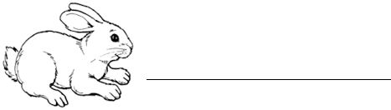

1. Why do parents take their children for immunization?

____________________________________________________________________________________________________________

1. Give any **one** reason why a mosquito is grouped under insects.

______________________________________________________

1. How does a bee protect itself?

______________________________________________________

1. Write any **one** reason why causalties are given first aid.

______________________________________________________

1. Name any **one** danger caused by heavy rainfall to people.

_____________________________________________________

1. How is a dustbin useful in a school?

______________________________________________________

1. Give the function of a zebra crossing on busy roads.

____________________________________________________________________________________________________________

1. Name any **one** example of a crop that grows well in swampy area.

______________________________________________________

1. Which component of the environment helps a P.3 child to fly kites?

______________________________________________________

1. What food value do we get from eating eggs?

______________________________________________________

1. Why do we wash our hands before eating food?

____________________________________________________________________________________________________________

1. Name the main source of heat and light in the environment.

______________________________________________________

1. Mention any **one** place where people get food in the environment.

______________________________________________________

1. Give one reason why people bathe daily.

______________________________________________________

1. How is part marked **Y** useful to a bird?

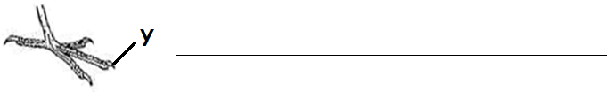

1. How do birds make use of trees?

____________________________________________________________________________________________________________

1. Name any **one** item used in harvesting rain water.

______________________________________________________

1. How is the garden tool below useful to a farmer?

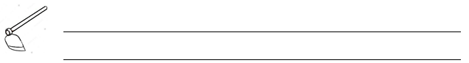

1. Give the function of antennae to an insect.

____________________________________________________________________________________________________________

1. Why do bees visit flowers?

______________________________________________________

1. How is a tongue useful to people?

______________________________________________________________________________________________________________

1. State the property of air shown below.

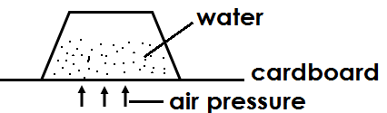

______________________________________________________

1. Give any **one** way food is useful in our bodies.

______________________________________________________

1. Why is oxygen not used in fire extinguishers?

____________________________________________________________________________________________________________

1. Name any **one** example of wild animal you know.

______________________________________________________

1. Why is a spider not regarded as a true insect?

____________________________________________________________________________________________________________

1. In which season is harvesting done?

______________________________________________________

1. What is soil erosion?

____________________________________________________________________________________________________________

1. Fish is to swimming as ____________________ is to gliding.
2. Give **one** condition needed for a seed to germinate.

______________________________________________________

1. What are vectors?

____________________________________________________________________________________________________________

1. What is formed when plants and animals decay?

______________________________________________________

**SECTION B**

1. The diagram below shows the lifecycle of an insect. Study it and answer the questions that follow.

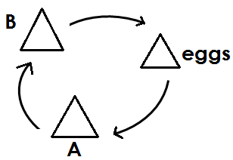

1. Name the life stages marked **A** and **B**
2. A : _____________________
3. B : _____________________

b) Mention any **one** insect that passes through the above stages of

growth.

_____________________________________________________

c) On which body part of an insect are the wings and legs attached?

______________________________________________________

1. (a) What is germination?

________________________________________________________________________________________________________

b) List down **two** conditions needed for a seed to germinate.

(i) __________________________________________________

(ii) __________________________________________________

c) Mention any **one** type of germination.

______________________________________________________

1. Circle the odd man out from the lists given below.

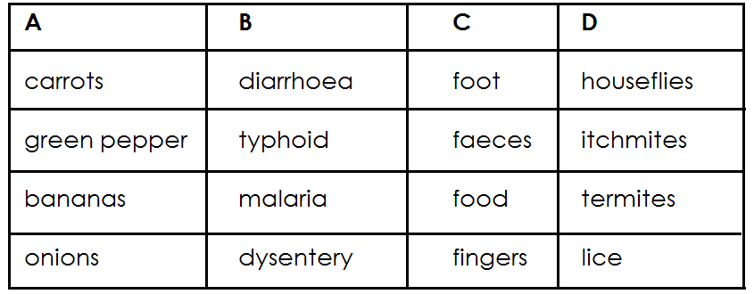

1. Draw and name any **two** types of weather.



(b) Give any **two** dangers of too much rain to people.

(i) ______________________________________________

______________________________________________

(ii) ______________________________________________

______________________________________________

1. Name the animals which provide us with the following;
2. milk : __________________________________
3. wool : __________________________________
4. transport : __________________________________
5. security : __________________________________
6. Read and write **‘True’ or ‘false’**
7. Bees visit flowers to carry out pollination. _____________
8. Spiders are not true insects. _____________
9. A seed is a young plant. _____________
10. A bird uses its spur for defence. _____________
11. The circles below show groups of food stuffs. Study it and answer the questions that follow.

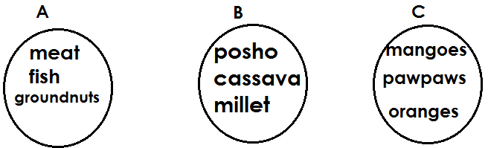

1. Which circle has foods that give us energy?

_________________________________________________

1. Write down **one** food stuff that you can eat to build your body.

_________________________________________________

1. Which circle has food that keep the body healthy?

_________________________________________________

1. Give **one** word that means the class of food stuffs in circle **‘C’**

_________________________________________________

1. (a) What are domestic animals?

______________________________________________________________________________________________________

(b) Mention any **two** animals that are used for transport.

(i) ______________________________________________

(ii) ______________________________________________

c) State any way of caring for domestic animals.

__________________________________________________

1. Study the diagram of a leaf below and answer the questions that follow.

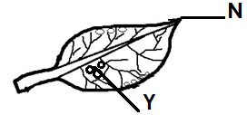

1. Name the type of leaf shown above.

__________________________________________________

1. Give any **one** plant with such type of leaf.

__________________________________________________

1. How is part **N** useful to a leaf?

____________________________________________________________________________________________________

1. State the function of part marked **Y.**

____________________________________________________________________________________________________

1. (a) What is the difference between air and wind?

____________________________________________________________________________________________________

b) Which component of air;

(i) supports burning? _________________________

(ii) used in germination? _________________________

c) Why is carbondioxide used in fire extinguishers?

__________________________________________________

__________________________________________________

1. Match animals and their movements correctly.

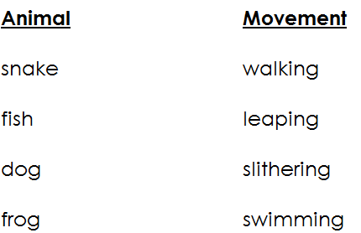

**Animal Movement**

1. snake _____________________________
2. fish _____________________________
3. dog _____________________________
4. frog _____________________________
5. (a) Name any **one** item used in cleaning our body.

__________________________________________________

b) Give **one** reason why people iron their clothes.

__________________________________________________

__________________________________________________

c) Mention any **two** activities done to keep our bodies clean.

(i) ______________________________________________

(ii) ______________________________________________

1. (a) Give any **one** condition of weather.

__________________________________________________

b) How is prolonged sunshine dangerous to farmers?

__________________________________________________

__________________________________________________

c) Write any **one** item used by people to protect themselves

from rainy weather.

__________________________________________________

d) Which type of weather enables a farmer to dry his harvested

crops?

__________________________________________________

1. (a) Write the diseases spread by the following vectors.
2. tsetse-flies : _________________
3. a female anopheles mosquito : _________________

b) State **two** ways of controlling vectors.

(i) ______________________________________________

(ii) ______________________________________________

1. State any **four** uses of water.
2. __________________________________________________
3. __________________________________________________
4. __________________________________________________
5. __________________________________________________

**THE END**